Summary: The SARIMAX model and the endogenous variable of water volume did not fit the data properly. Exogenous variables were introduced to explain the model better. After this introduction, the SARIMAX model produced an adjusted r-squared of 61% when measuring the data after COVID. The limitations of this model are the evolving economic circumstances surrounding oil production in East Texas or any other unexplained or plausible headache regarding the disposal water volume.
Introduction: The core issue in this project is finding seasonality in the data. Saltwater disposal volumes have fluctuated since the beginning of the observed data (01-01-1998). The data was cleaned and organized into two columns (‘Date’, ‘Water Volume’). Date being the observation date/month, and water volume being the total saltwater disposal volume of said month.
Methodology: The data is a simple series so the first step in preparing for the model is making sure that the data is stationary. After differencing the data once, the Augmented Dickey-Fuller test was used to check for stationarity. This was a success.
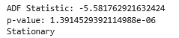
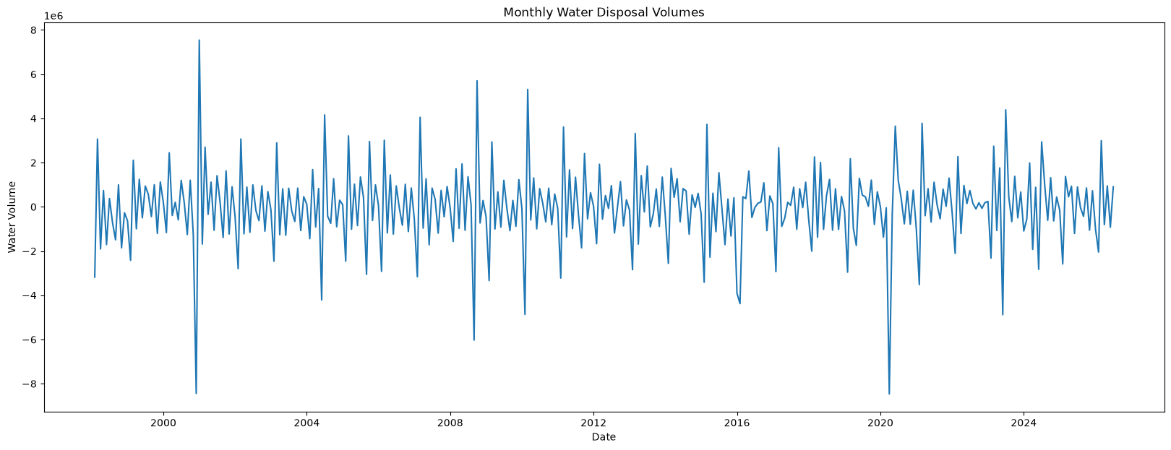
Next, an ACF and PACF test were conducted to show where the autocorrelation was in the data.

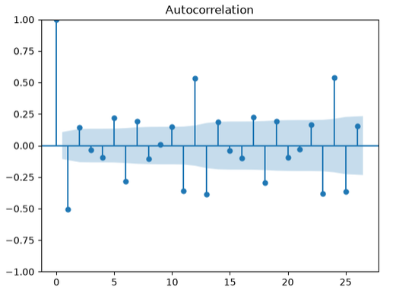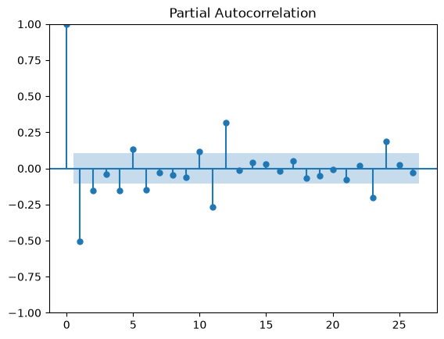
It should be noted that the first lag is negative reveals that the high positive values tend to come before low positive values. This could be due to the data having large, unpredicatble jumps up and down. A good insight into how the data behaves is on the 11th through 13th. The negative, significant dip of the 11th lag immediately precedes the 12th positive significant lag. This bahavior is predictable, but also a yearly cycle where the positive lags at the 12th and 24th position indicate strong correlation to lag 0.
Using the auto arima function to solve which parameters would be best for the SARIMAX model, we find that ARIMA(1, 1, 0)(1, 0, 2, 12) is the best model.
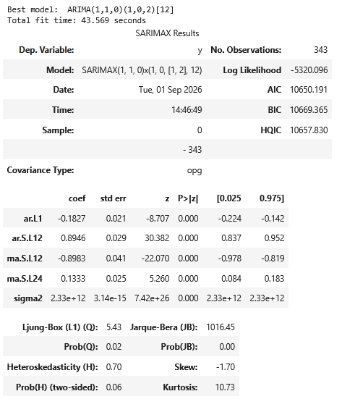

The parameters are listed as follows: ARIMA(p, d, q)(P, D, Q, s), where p is the autoregressive term, d is the differencing term, q is the moving average term. P, D, and Q are all seasonal parameters that mean the same exact thing as the previous parameters but the seasonal term s is applied to them.

In addition to the endogenous time series variable, saltwater disposal volume, two additional sources were introduced to help with the unexplained error in the model. The first source is the Brent Crude price index from the FRED website. This data was introduced to explaine the varied entries in disposal volume, i.e., the price of oil increases which may increase the firms disposal volume. The second source of information was the Texas Railroad Commision and their East Texas oil production data. This would help explain why the disposal volume has fallen over the past twenty years which helps the accuracy of the model.
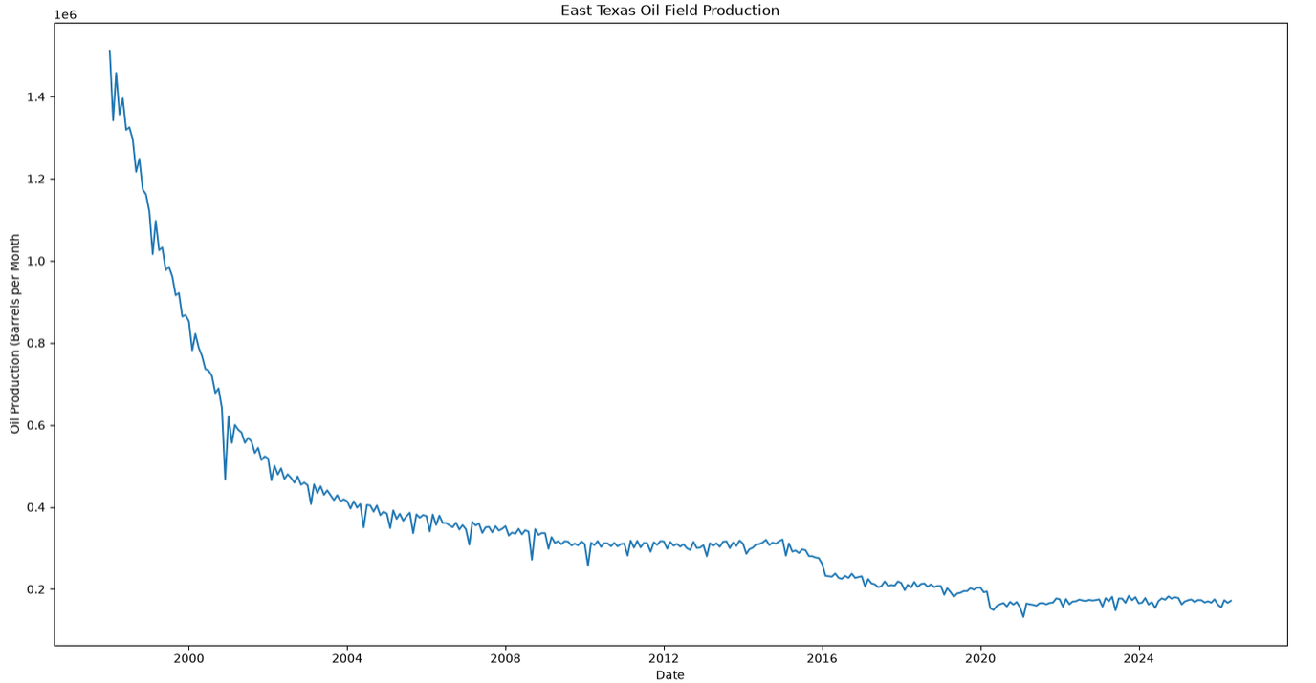

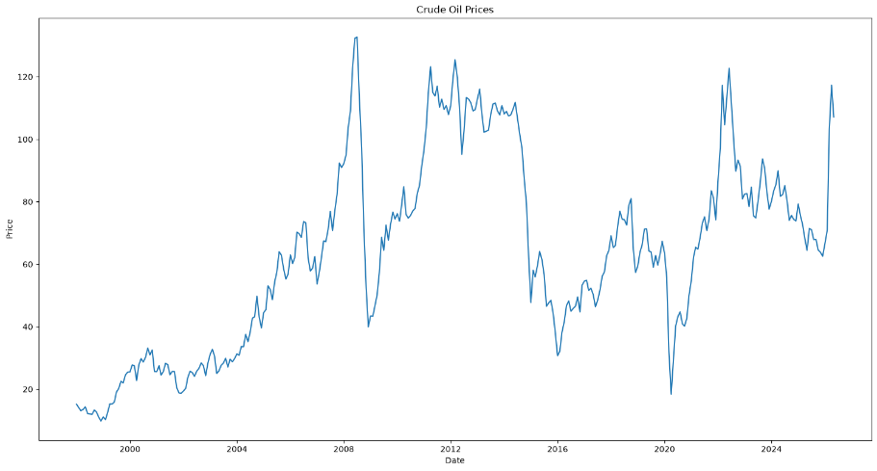

Results: Now that all the data and necessary modeling information has been collected. The SARIMAX model could now be programmed. The model was given training data from 1998-01-01 to 2025-04-01. The model uses this data to predict the next outcomes. Our validation data was set for 2025-05-01 to 2026-05-01. The SARIMAX will then compare its prediction to the validation data.
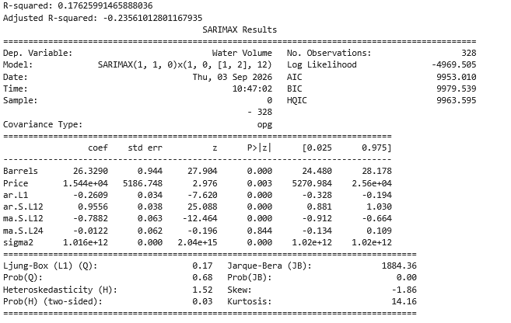
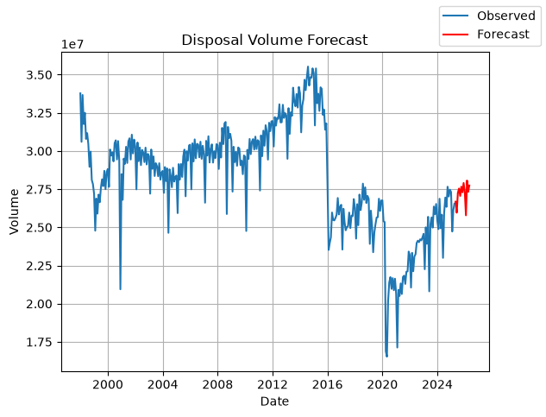
This was not expected. The adjusted r-squared is negative and the model does little to explain the previous twenty years of company data. A second test was conducted on the data after COVID, 2021 – 2026.
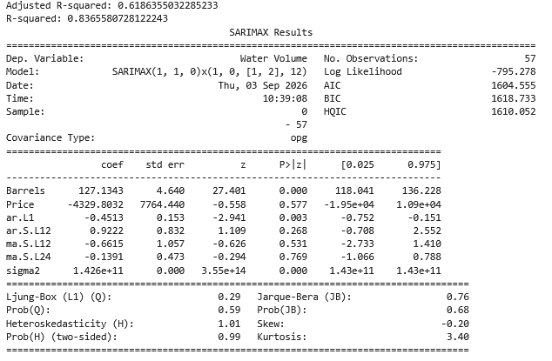
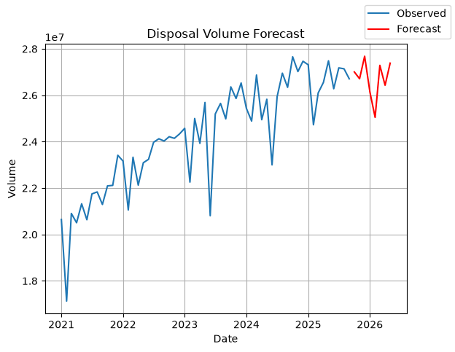
The adjusted r-squared value significantly higher than the previous test. Nearly 62% of the model is explained by the variance in the data. The post-COVID economy has been relatively stable which helps the model and its prediction. The disparity in disposal volume over the past twenty years restricts the model’s ability because COVID and oil price shocks are naturally unpredictable. Stationary data that allows consistent variability will be more predictable more often. Isolating the post-COVID period reduced the observation number drastically, though. Fifty-seven observations total is what we must work with. Further observations and testing will be conducted to ensure the legitimacy of the model.

